CSC 403 ICE 2

Name Brian Bauman

This is a graded activity and is intended to mirror the in-class interactive exercises.

You can simply edit this document and upload to the submission folder by the due date/time shown there. You can also write it out by hand, scan it and then upload that.

1. Give the code that will manually build the tree shown. You may find the BasicBinaryTree.java program (week 2 folder) useful.

Node n1 = new Node(10);

Node n2 = new Node(4);

Node n3 = new Node(1);

Node n4 = new Node(8)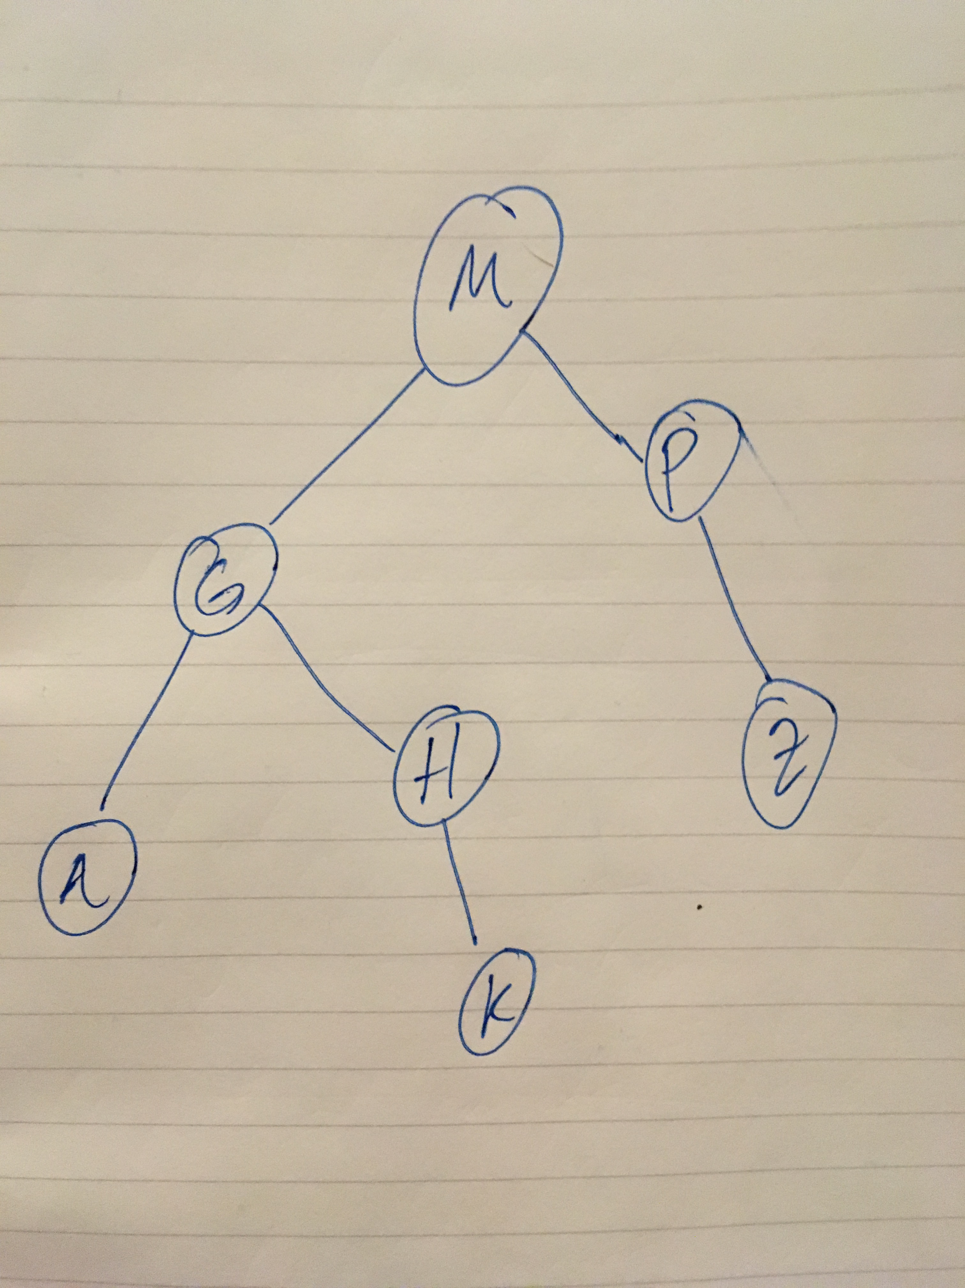;

Node n5 = new Node(25);

Node n6 = new Node(20);

Node n7 = new Node(30);

n1.left = n2;

n1.right = n6;

n2.left = n3;

n2.right = n4;

n4.left = n5;

N6.right = n7;

1. What is the ‘property’ that characterizes a Binary Search Tree

Binary Search Trees are characterized by having, for each node, lesser values contained in the left subtree and greater values contained in the right subtree.

1. Draw a binary search tree using the keys A G H M K P Z.

Hint: there are many answers. Draw one of them.

1. Do an InOrder traversal of the tree from question 1.

1, 4, 25, 8, 10, 20, 30

Questions and/or comments about the second class are welcome.